

owasp ZAP

Assignment 6



***Internee.pk***

September 9, 2025

Our task is to perform penetration testing on OWASP juice shop with help of ZAP or Burpsuit. We have used ZAP for our task install it from the official website and also download Java for runtime environment

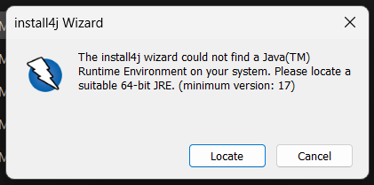

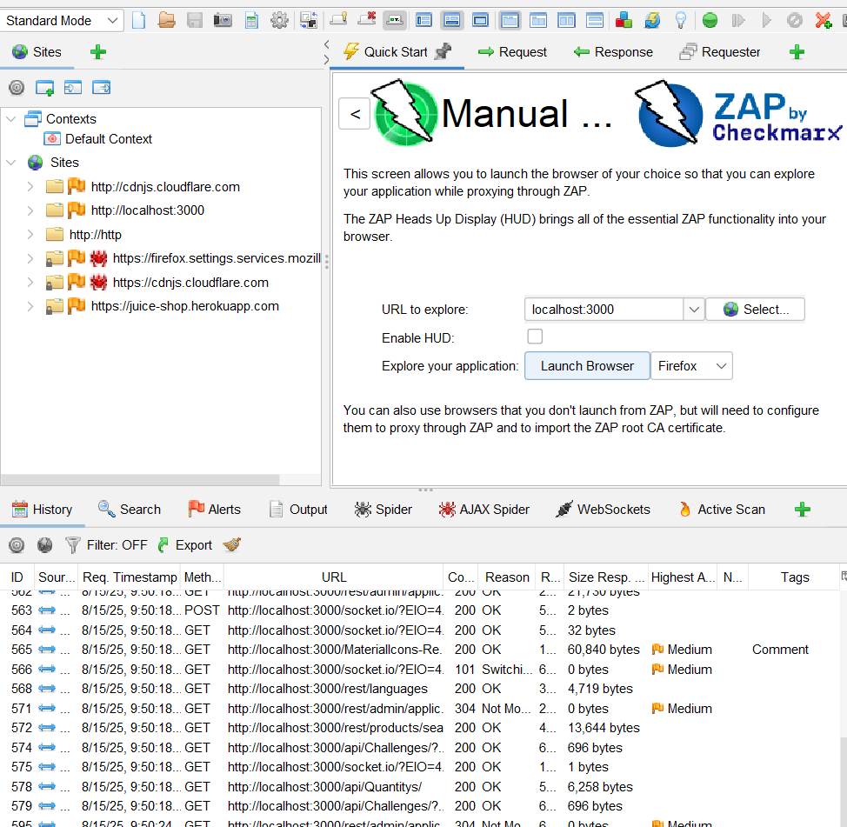

Run the script ***docker run –rm –p 3000:3000 bkimminich/juice-shop*** and it will download the web to load on your local host

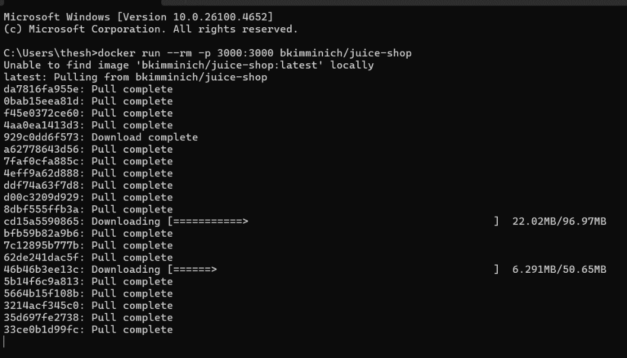

Open ZAP enter the manual URL and proceed to the website here you will be asked to register and login

Here we will perform SQL injection as requirement in username we wrote **‘OR’1’=1** and in password **anything.**

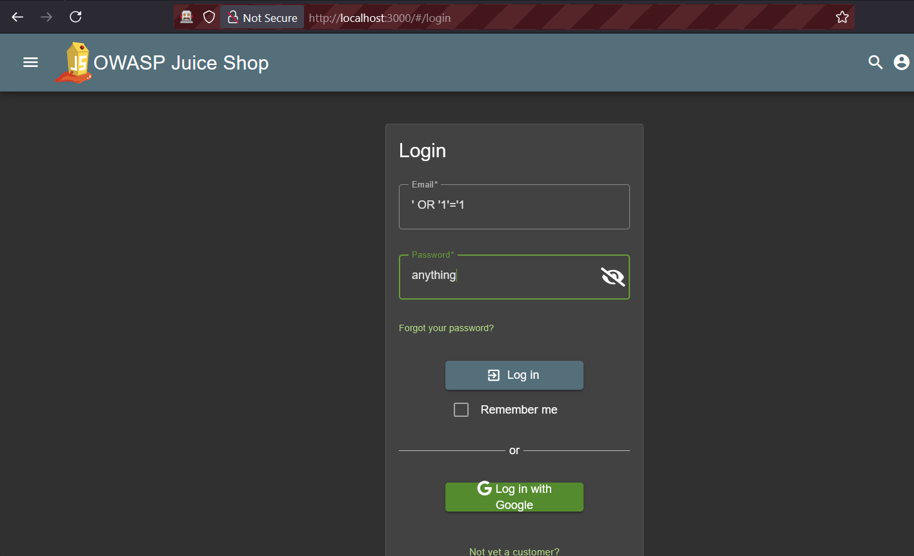

After performing SQL injection we have successfully logged in to juice shop you can view in ZAP our request has been captured were we end the SQL injection

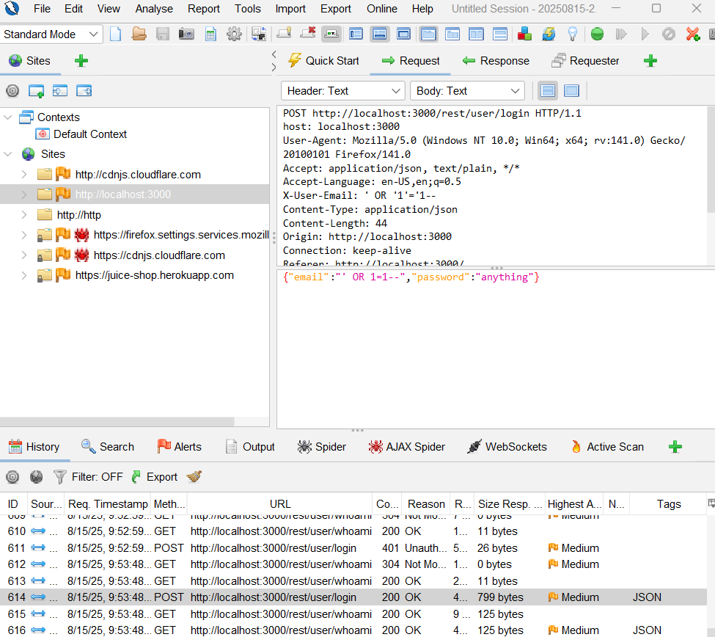

Our other requirement is to login as administrator we will first register our self and then we will login again by SQL injection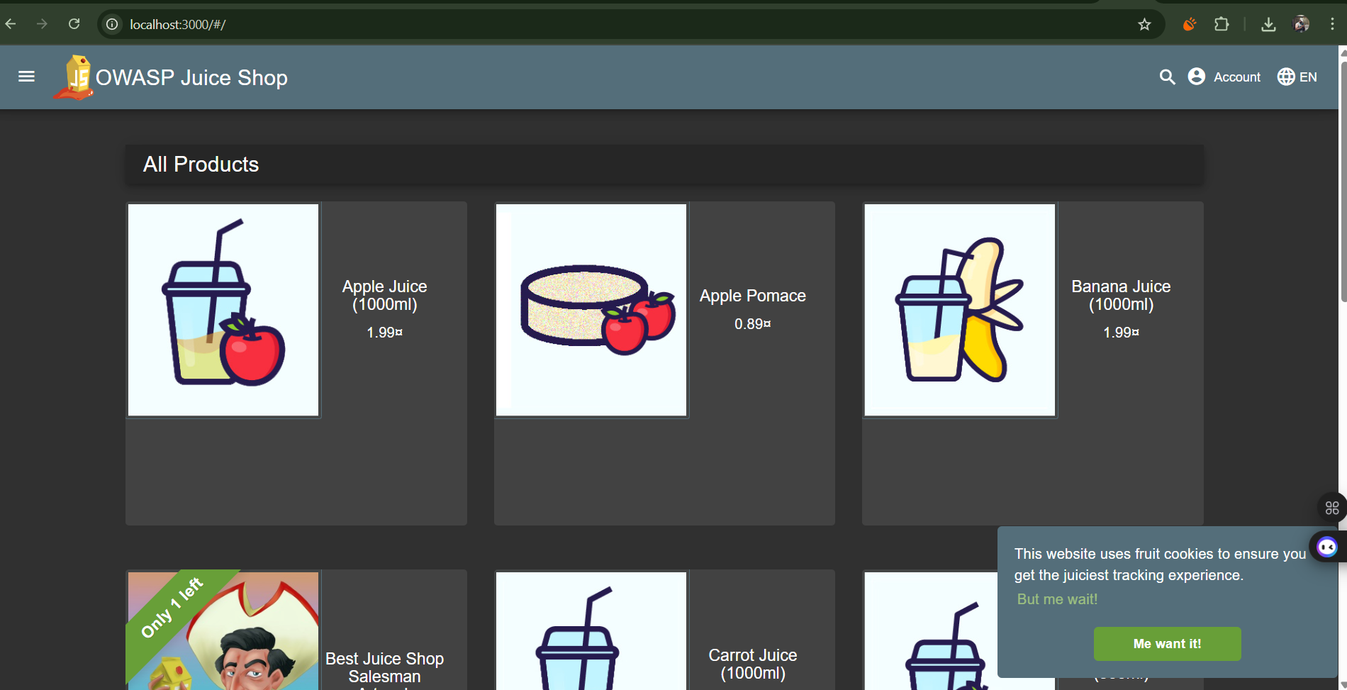

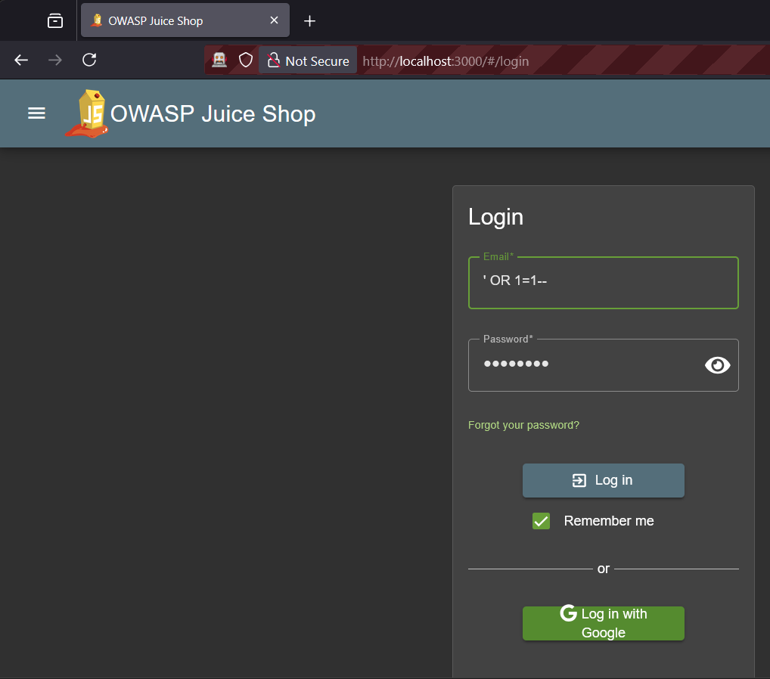

We successfully logged in as Admin

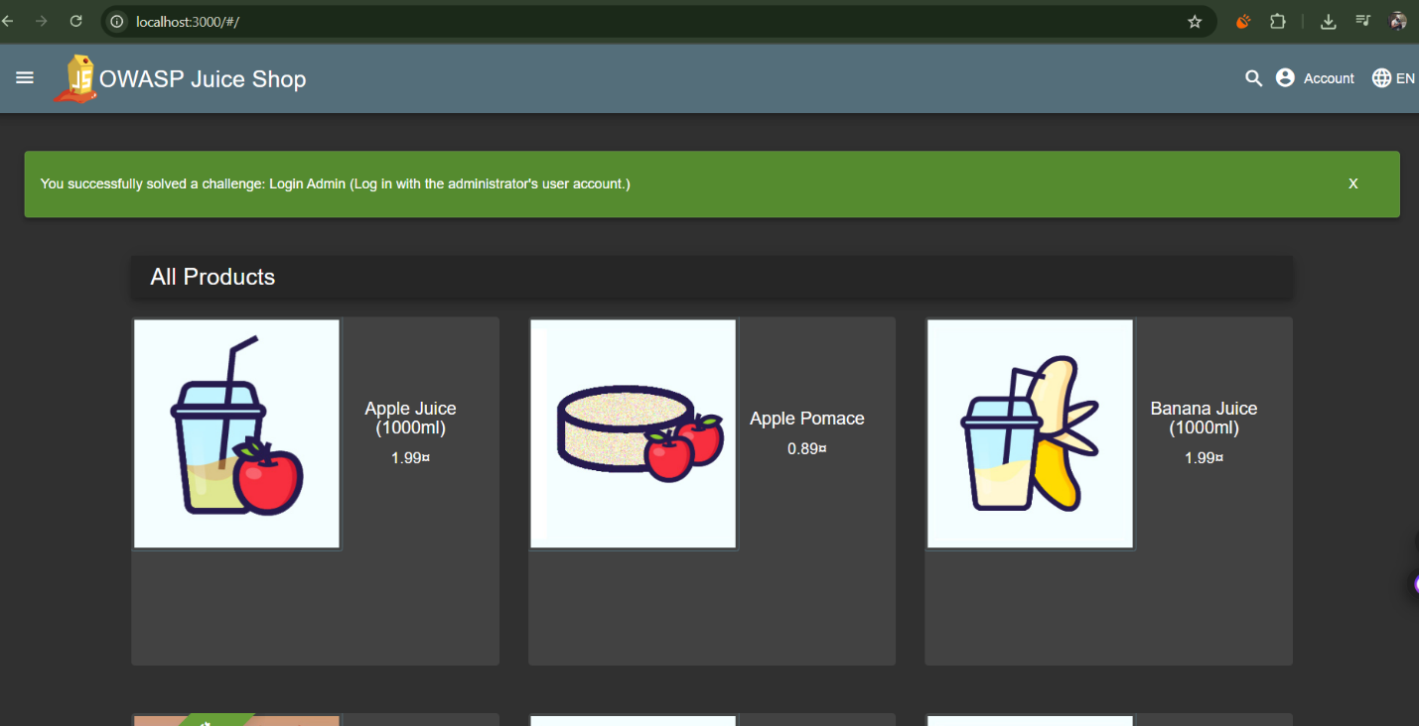

Secondly we were given to perform XSS a script was injected in search bar of the menu

